COUNSELZ: A CAREER GUIDIMG APPLICATION USING ANGULAR JS AND NODE JS

## A PROJECT REPORT

***Submitted by,***

# SURYAK (21IT082)

# RITHISH R S (21IT108)

**SUBIKSHUN (21IT133)**

**DEEPAK RAJ A(21IT124)**

***In partial fulfillment for the completion of the course Web Technologies***

***of***

**BACHELOR OF TECHNOLOGY**

**IN**

**INFORMATION TECHNOLOGY**

# THIAGARAJAR COLLEGE OF

**ENGINEERING (AGovt. Aided, Autonomous Institution,Affiliated to Anna University)**

OCTOBER, 2023

# THIAGARAJAR COLLEGE OF ENGINEERING

**(AGovt. Aided, Autonomous Institution,Affiliated to Anna University)**

# BONAFIDE CERTIFICATE

Certified that this project report **“COUNSELZ: A CAREER GUIDING APPLICATION USING ANGULAR JS AND NODE JS”** is the bonafide work of **RITHISH R (21IT1082), SURYA K (21IT108), SUBIKSHUN**

**(21IT133), DEEPAK RAJ A(21IT124)** who carried out the project work under my supervision.

**SIGNATURE SIGNATURE**

**DR. SRIDEVI S DR. AKILA RANI M**

ASSOCIATE PROFESSOR, ASSISTANT PROFESSOR

DEPARTMENT OF INFORMATION DEPARTMENT OF INFORMATION

TECHNOLOGY, TECHNOLOGY,

THIAGARAJAR COLLEGE OF THIAGARAJAR COLLEGE OF

ENGINEERING. ENGINEERING.

# ABSTRACT

[Education](https://www.toppr.com/) is an important tool which is very useful in everybody’s life. Education is what differentiates us from other living beings on earth. It makes man the smartest creature on earth. It empowers humans and gets them ready to face challenges of life efficiently. With that being said, education still remains a luxury and not a necessity in our country. Educational awareness needs to be spread through the country to make education accessible. But, this remains incomplete without first analyzing the importance of education. Only when the people realize what significance it holds, can they consider it a necessity for a good life. But what if you get proper guidance, and enter into a dark door.

So, here comes Counselz, an online application that aims you to connect to the significant Counsellor to write your destiny in your hands

## TABLE OF CONTENTS

|  |  |  |
| --- | --- | --- |
| **CHAPTER NO** | **TITLE** | **PAGE NO** |
|  | **ABSTRACT** | **iii** |
|  | **LIST OF FIGURES** | **v** |

|  |  |  |
| --- | --- | --- |
| **1** | **INTRODUCTION** | **1** |
| 1.1 | BACKGROUND | 1 |
| 1.2 | OBJECTIVES | 1 |
| **2** | **SYSTEM ARCHITECTURE** | **2** |
| 2.1 | OVERVIEW | 2 |
| 2.2 | FRONTEND (ANGULARJS) | 2 |
| 2.3 | BACKEND (NODEJS) | 2 |
| 2.4 | DATABASE (MONGODB) | 3 |
| **3** | **DESIGN AND IMPLEMENTATION** | **4** |
| **4** | **FEATURES AND FUNCTIONALITY** | **8** |
| 4.1 | USER REGISTRATION AND LOGIN | 8 |
| 4.2 | MOVIE LISTING | 9 |
| 4.3 | FIND TRENDING MOVIES | 9 |
| 4.4 | USER PROFILE | 9 |
| 4.5 | ADMIN PANEL | 9 |
| 4.6 | MOVIE WATCHLIST MANAGEMENT | 10 |
| **5** | **TESTING** | **10** |
| 5.1 | UNIT TESTING | 10 |
| 5.2 | INTEGRATION TESTING | 11 |
| 5.3 | ACCESSIBILITY TESTING | 12 |
| 5.4 | PERFORMANCE TESTING | 12 |
| **6** | **KEY TAKEAWAYS** | **15** |
| **7** | **CONCLUSION** | **15** |

**LIST OF FIGURES**

|  |  |  |
| --- | --- | --- |
| FIGURE NO | TITLE | PAGE NO |
| 3.1 | Counselz Home page | 4 |
| 3.2 | Assessment page | 5 |
| 3.3 | description page | 5 |
| 3.4 | councillers page | 6 |
| 3.5 | session page | 6 |
| 3.6 | Signup page | 7 |
| 3.7 | Login page | 7 |
| 3.8 | Review page | 8 |
| 3.9 | Counselz Database (MongoDB) | 11 |
| 5.1 | Unit testing of sessions page | 11 |
| 5.2 | Unit testing of Login page | 13 |
| 5.3 | Performance and Accessibility test of Home page | 14 |
| 5.4 | Performance and Accessibility test of reviews page | 19 |

V

## INTRODUCTION

* 1. **BACKGROUND**

Education is one of the key components for an individual’s success. It has the ability to shape one’s life in the right direction. Education is a process of imparting or acquiring knowledge, and developing the powers of reasoning and judgement. It prepares growing children intellectually for a life with more mature understanding and sensitivity to issues surrounding them. So what if someone knocks the wrong door and enter into a horrible future.

Our journey begins with enlightening the students with their potentials and connect them with a reliable counsellor so that they can decide about their career.

## OBJECTIVES

The primary objectives of the "Counselz" project are as follows:

* + - Assessment and Self Understanding: Help individuals assess their skills , interests, strengths weakness and personality traits to get a better understanding of themselves and provide marks .
    - Education Planning: Assist in choosing appropriate educational programmes or courses based on their marks.
    - Counselling Planning- Arrange meetings with appropriate counsellors so that they can get appropriate idea with their career ideas based on the marks
    - Goal Setting and Action Planning: After assisting the individuals with the help of the counsellors, make them to follow a routine.
    - Gratitude messenger: Collect feedbacks from customers and use it as a testimonial for the next customer.

## SYSTEM ARCHITECTURE

* 1. **OVERVIEW**

“Counselz” is an online application that aims to guide you to decide an appropriate decision in your life with a help of an assessment so that you could build your career.

## FRONTEND (ANGULARJS)

* + - "Counselz" leverages AngularJS to provide a dynamic and interactive user interface. Its key AngularJS features include responsive design, enabling seamless access from various devices. The application offers robust search functionality, allowing users to book counselling session, take tests to assess their skills.
    - It utilizes AngularJS to implement a recommendation engine, suggesting counsellors based on a user’s marks.
    - This framework enables the users to take an assessment to check out their abilities and connect them with an appropriate counsellor
  1. **BACKEND (NODE JS)**
     + "Counselz" relies on Node.js for its backend functionality, offering a robust and scalable server-side infrastructure. Node.js facilitates seamless integration with external APIs, ensuring real-time access to data.
     + It enables secure user authentication, safeguarding user data and details. The application utilizes a database system to store user information, counsellor’s information and the test marks of an individual.

## DATABASE (MONGODB)

* + - Flexible Schema: MongoDB's schema-less design allows "Counselz" to adapt to changing data requirements without disrupting operations. This flexibility is crucial for handling diverse test information and user profiles.
    - Scalability: As the user base grows, MongoDB ensures horizontal scalability by distributing data across multiple servers. This feature guarantees that "Counselz" can accommodate an increasing number of users.
    - Real-time Data: MongoDB is well-suited for real-time applications like "Counselz" because it supports fast reads and writes. This is essential for delivering up-to-date counsellor information.

## DESIGN AND IMPLEMENTATION



**Figure 3.1 Counselz Home page**

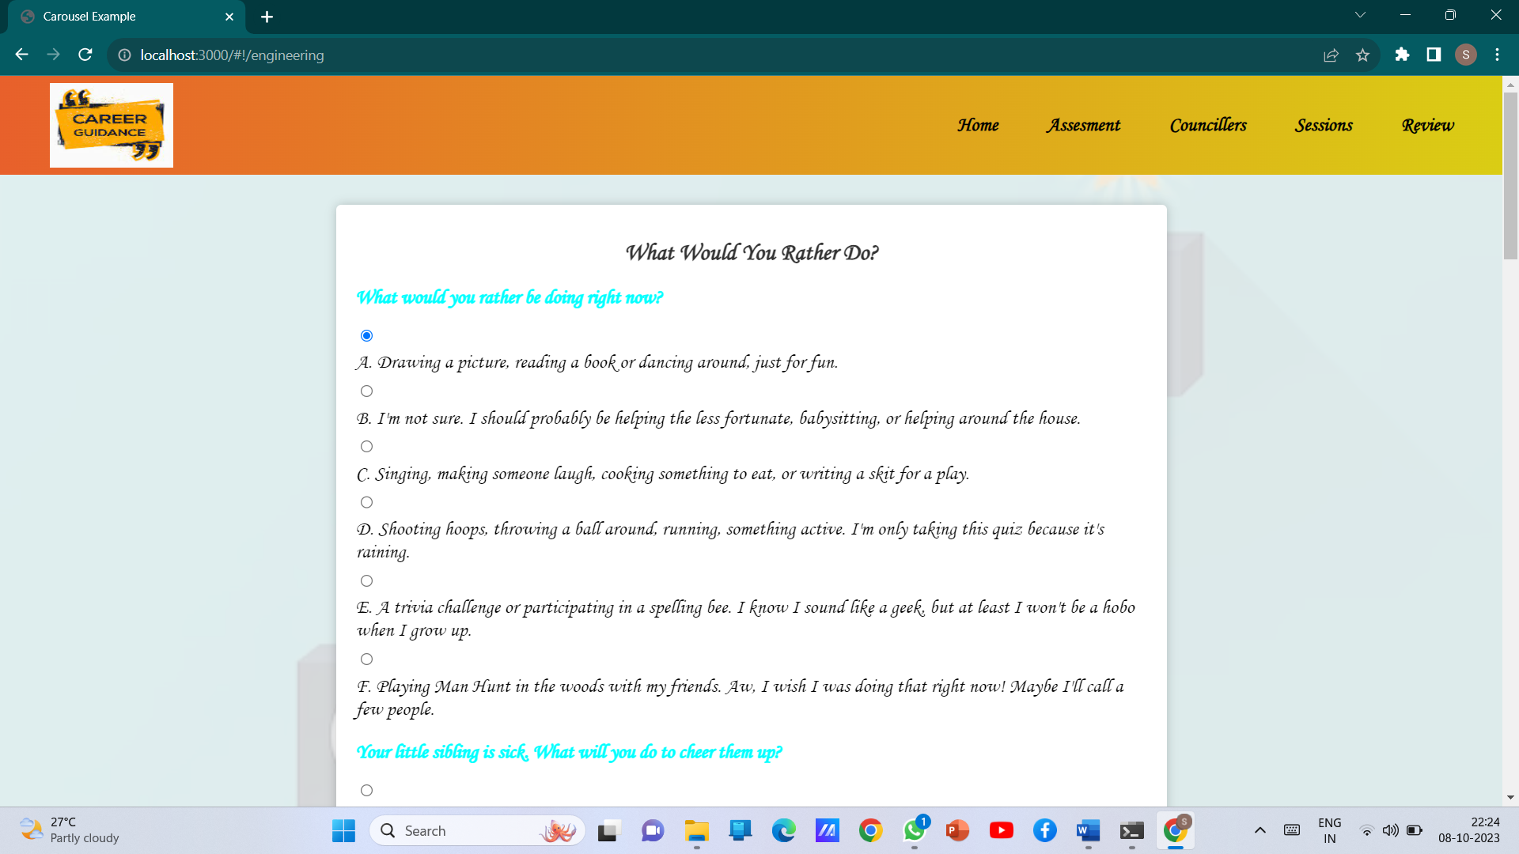

## Figure 3.2 Assessment page



**Figure 3.3 description page**

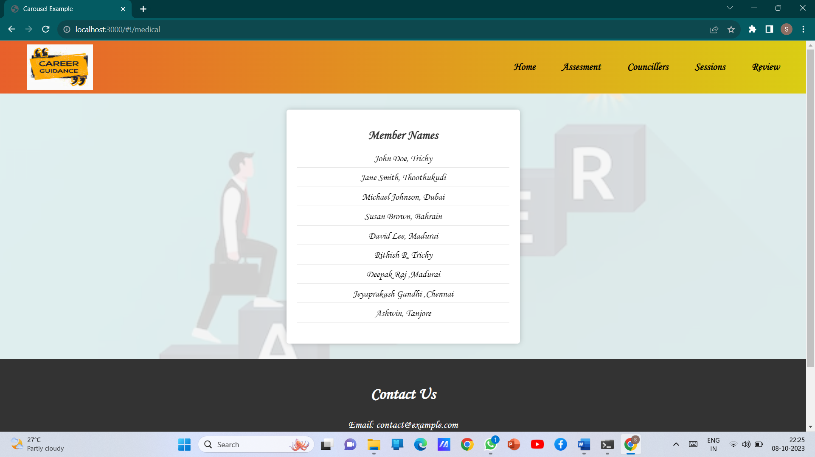

## Figure 3.4 councillers page

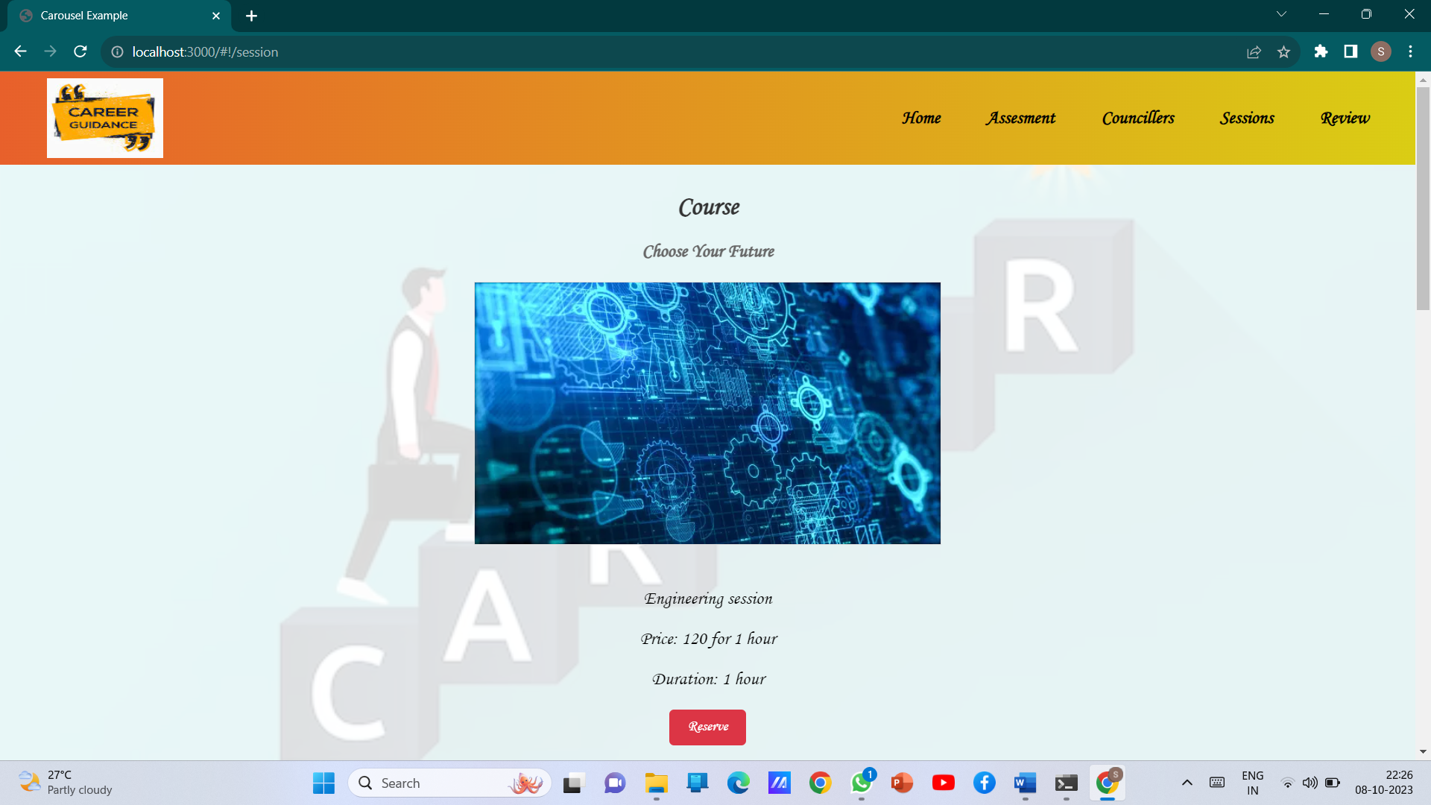

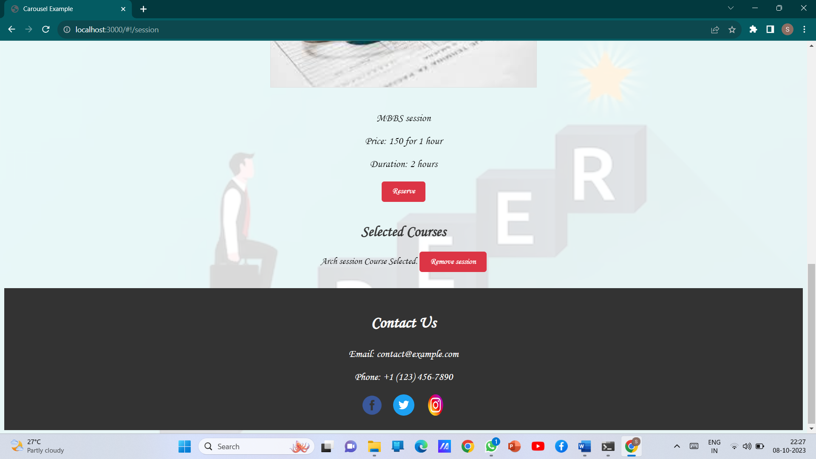

**Figure 3.5 session page**

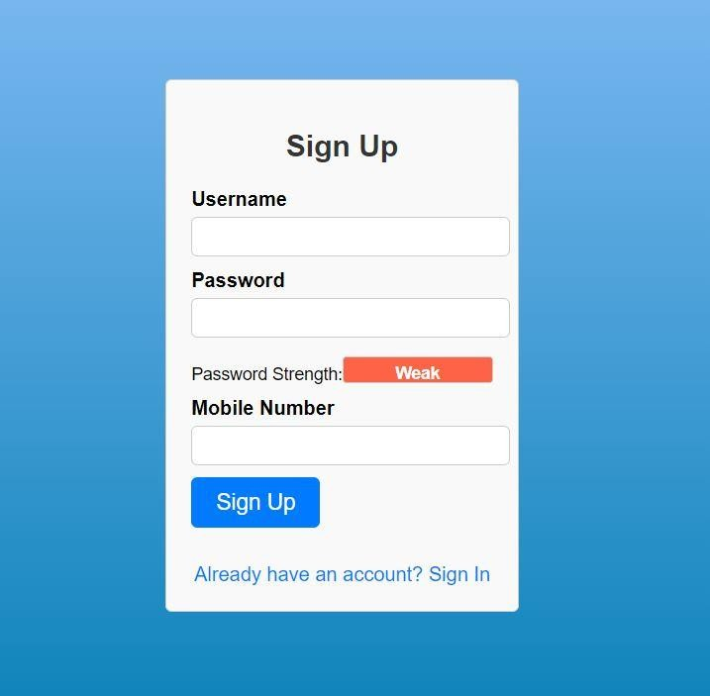

## Figure 3.6 Signup page

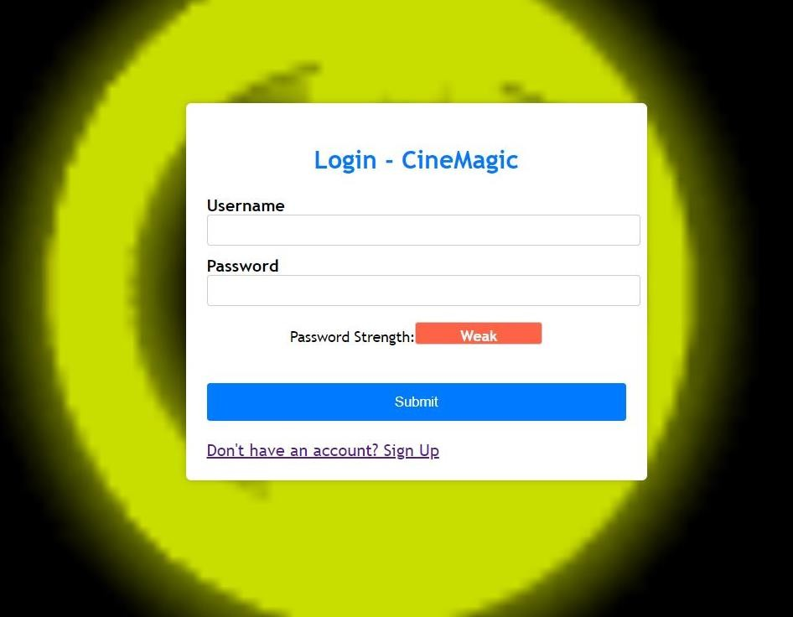

**Figure 3.7 Login page**

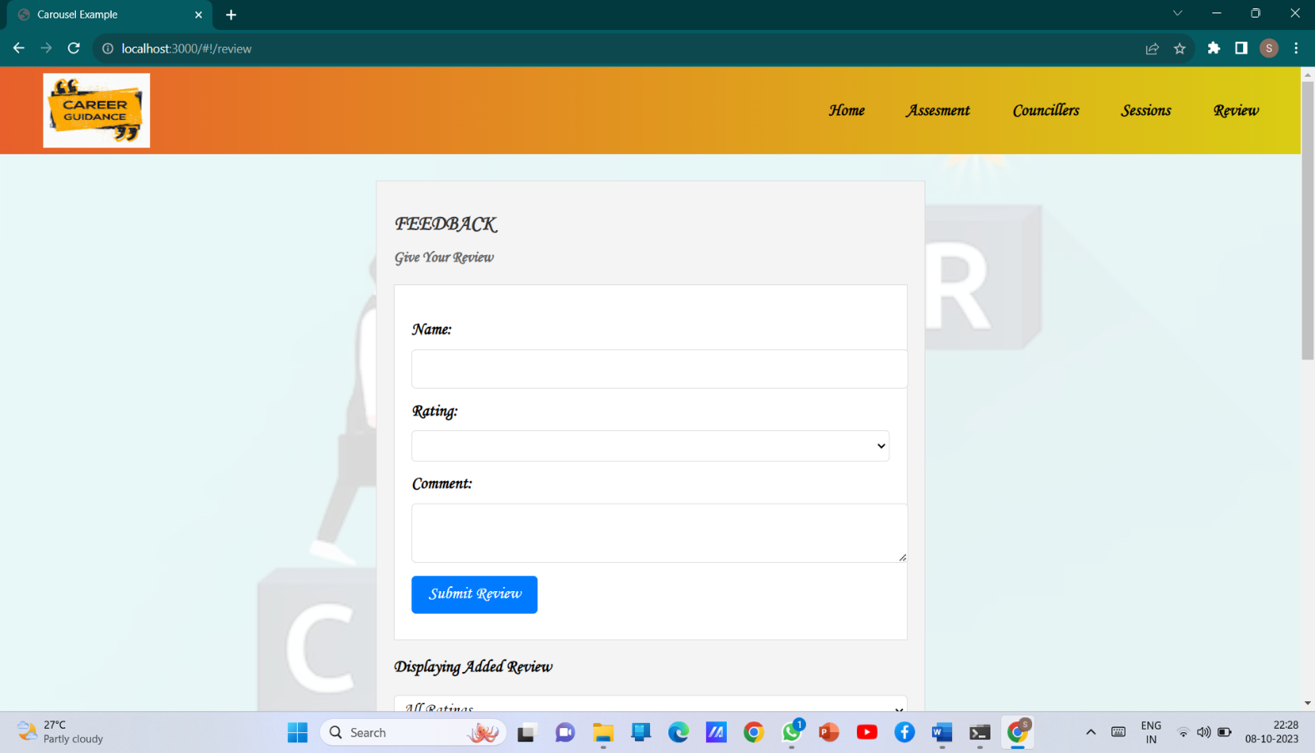

## Figure 3.8 Review page

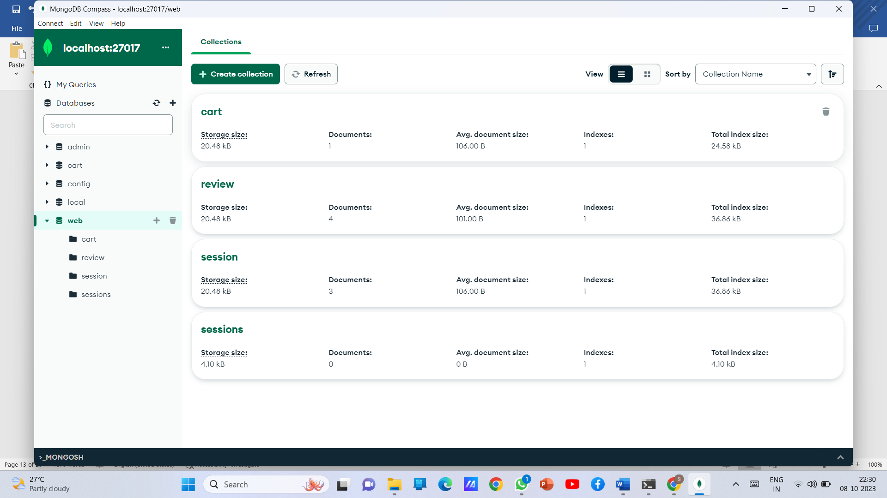

**Figure 3.9 Counselz Database (MongoDB)**

## FEATURES AND FUNCTIONALITY

This section elaborates on the key features and functionalities of the "Counselz" Counselling management platform, highlighting the user registration and login system, testing an individual, find appropriate counsellors, user profiles, feedback session, and tracking an individual.

## USER REGISTRATION AND LOGIN

* + - Social Media Integration: Users can register and log in using their social media accounts, streamlining the onboarding process and enhancing user convenience.

## Assessing an Individual

* + - Testing pattern: Testing an individual by providing them with multiple choice questions and marking them with an certain grade so that they can understand their level.

## Guiding appropriate counsellors

* + - Personalized Recommendations: after testing an individual, connect them with the appropriate counsellor based on the marks from the test.

## Book Sessions

* Counselling Sessions: Make them to book counselling session on timely basis so that they could discuss their career plans with them.

## TESTING

This section discusses the testing methodologies employed in the development of the "Counselz" Counselling management platform. It includes unit testing, integration testing, performance testing, accessibility testing, and the procedures for tracking and resolving software bugs.

## UNIT TESTING

* + - Unit testing for the "Counselz" focuses on the examination of individual units or components of the software in isolation. Each unit, which typically corresponds to specific functions, methods, or classes, is evaluated independently to ensure that it functions correctly and produces the expected results.
    - Unit testing is an integral part of the development process for "Counselz" as it assists in maintaining code quality, identifying and rectifying issues at an early stage, and simplifying debugging efforts. By systematically isolating and testing individual units, the application can achieve a high level of reliability and performance.

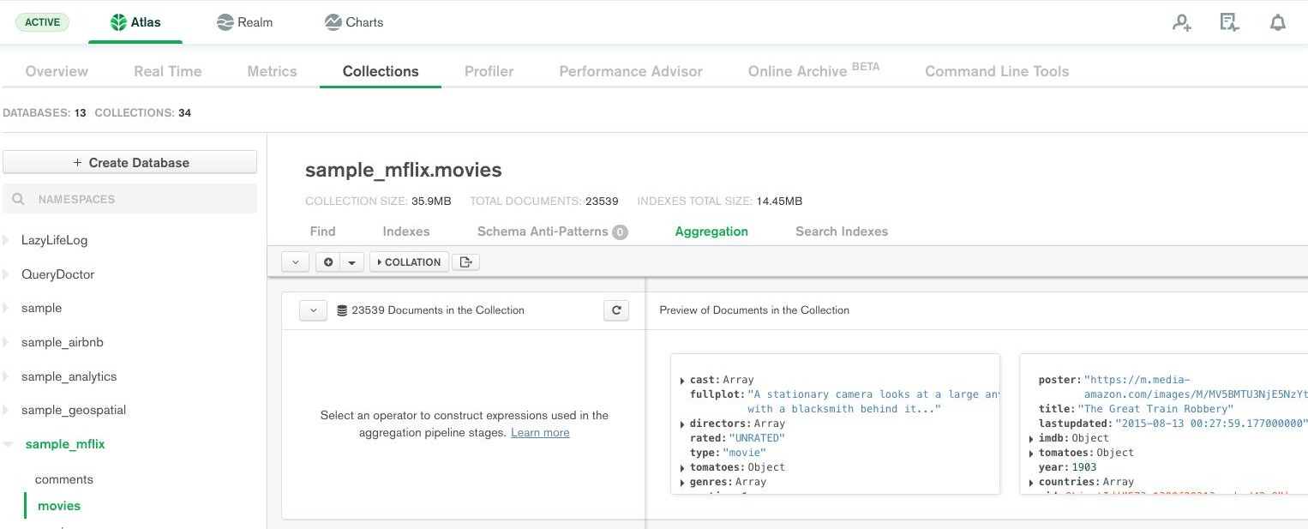

## Figure 5.1 Unit testing of sessions page

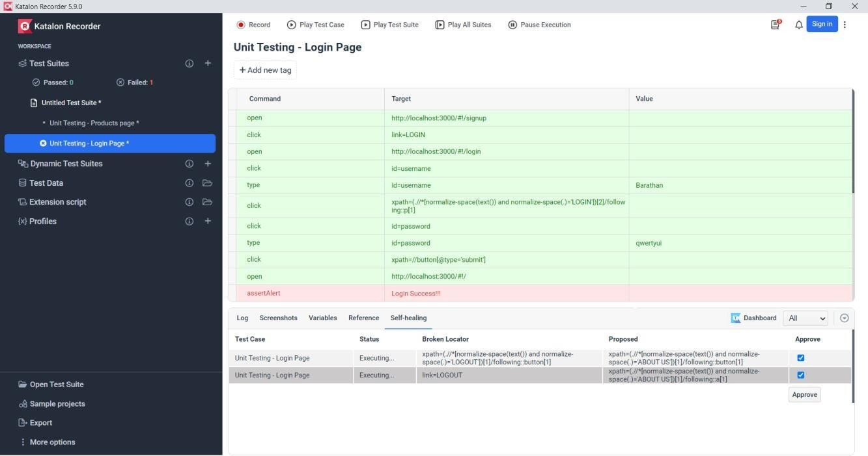

**Figure 5.2 Unit testing of Login page**

## INTEGRATION TESTING

* + - Integration testing for the "Counselz" counselling management application is aimed at assessing the seamless interaction and integration of various components an module when they are integrated into the complete system. This form of testing ensures that all the different facets of the application collaborate cohesively.
    - In the context of "Counselz," integration testing verifies that critical functions such as user registration and login work harmoniously with features like Counsellors listing, test management, and user profiles. It is essential to confirm that the integration of these components does not result in any data flow issues, communication problems between modules, or disruptions to the overall application's functionality.
    - The objective of integration testing is to detect and rectify integration-related bugs and to ensure that the application operates as a unified whole. By conducting these tests, "Counselz" can maintain a robust and glitch-free user experience.
    - Integration testing is a pivotal phase in the development process of the "Counselz" Counselling management application as it guarantees that the diverse elements of the application cooperate seamlessly, minimizing the risk of integration-related issues impacting user satisfaction and application stability.

## PERFORMANCE TESTING

* + - Performance testing for the "Counselz" Counselling management application is a critical phase aimed at evaluating the application's responsiveness, scalability, and overall efficiency under varying conditions and loads. This form of testing seeks to ensure that the application delivers a seamless and optimal user experience while adhering to performance requirements and expectations.
    - Load Testing: Load testing assesses the application's behavior under expected loads, examining how it performs when subjected to a predefined number of users or transactions. It verifies whether the application can maintain performance without degradation during typical usage scenarios.
    - Stress Testing: Stress testing pushes the application beyond its operational limits to identify potential bottlenecks, vulnerabilities, and failure points. By subjecting the application to extreme conditions, it helps pinpoint areas where performance improvements may be necessary.
    - Endurance Testing: Endurance testing evaluates the stability and resource utilization of the application over an extended period. It identifies any memory leaks, resource depletion, or performance degradation that may occur during sustained usage.
    - Spike Testing: Spike testing analyzes how the application responds to sudden and significant increases in user load or traffic, simulating real-world usage patterns and ensuring that it can handle unexpected surges in activity.

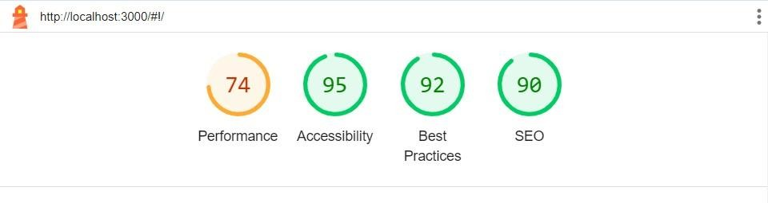

## Figure 5.3 Performance and Accessibility test of Home page

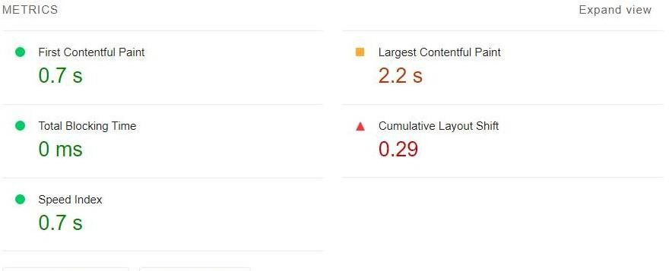



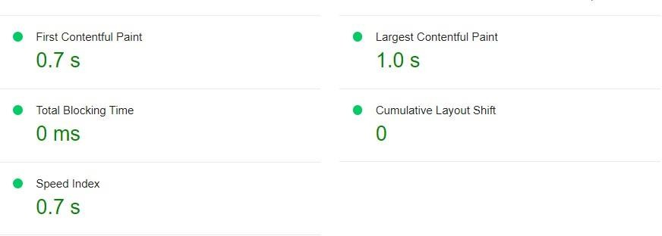

**Figure 5.4 Performance and Accessibility test of review page**

## KEY TAKEAWAYS

* Comprehensive Functionality: "Counselz" offers a wide range of features, including user registration and login, counsellors listing, assessing an individual, user profiles, an admin panel, and movie watchlist management.
* Testing Rigor: The project emphasizes the importance of rigorous testing, including unit testing, integration testing, and performance testing, to ensure the application's reliability, performance, and scalability. These testing phases are integral to delivering a seamless user experience.
* Technology Stack: "Counselz" leverages modern technologies such as AngularJS for the front-end, Node.js for the back-end, and MongoDB for the database. This stack provides the foundation for a responsive, secure, and feature-rich application.
* User-Centered Design: The project underscores the significance of user-centered design principles. Features like profile customization and social media integration enhance the user experience, fostering a sense of community among movie enthusiasts.

## CONCLUSION

In conclusion, “Counselz” help you to guide and track your skills and talents and leads you to the appropriate counsellors with the marks you have got. Choosing you career wisely is effectively needed as many of them are knocking the wrong doors and getting into traps. So we aim to build each and everyone’s career with their interest and skills for a better future.